|  |
| --- |
| Alectronic |
| Project Jam Jar |
| Online Local Market stall E-commerce |
|  |
| **Alec Doran-Twyford** |
|  |

|  |
| --- |
| [Type the abstract of the document here. The abstract is typically a short summary of the contents of the document. Type the abstract of the document here. The abstract is typically a short summary of the contents of the document.] |

Contents

Market Requirements Document 4

Market Analysis 4

Porters 5 Forces 4

Market Sizing 5

Financial Projections 5

Product Requirements Document 10

Technology 10

Roadmap 10

Product Life Cycle 11

Key metrics 12

Storyboarding, Wireframes & Prototyping 13

Business Requirements Document 21

Business Model 22

Value Proposition 23

Elevator Pitch

***Project Jam Jar****, is a* ***platform*** *to assist* ***market stall vendors*** *to* ***manage*** *and* ***sell*** *their* ***homemade******produce******online*** *to* ***customer*** *and* ***Wholesale Customers*** *(local shop & Restaurants).*

***Customers*** *will be able to* ***order from multiple vendors in one go*** *ie. Jam from one person and Bread from another all in one order.* ***All locally sourced****.* ***Vendors*** *would all have access to a* ***profile page*** *which will explain them and their products.*

***Project Jam Jar*** *is here to* ***empower local markets*** *by* ***getting business online****. Though* ***Local sustainability*** *can we* ***create global sustainability.***

# Market Requirements Document

# Market Analysis

**Who are we targeting?**

- People who produce homemade produce (Jams, Chutneys, Cakes, Bread, Drinks, Beer, Sprits, ect)

- Customer who wish to purchase Homemade produce and wholesale customer (people who run local shops, bar, restaruants).

**What are the demographics of your market?**

- People of all ages (targeted at 25- 45 age)

- People who love locally source produce, support local business and sustainability.

- Sydneysider who go to farmers markets.

- People who shop online.

What products are in competition with the proposed one?

http://www.harrisfarm.com.au/

http://www.foodguru.com.au/

http://www.gourmetgroceronline.com.au/

http://fromtheproducer.com/

http://www.farmhousedirect.com.au/

http://www.graysonline.com/

**What does success look like in terms of market penetration?**

Getting 40% of Sydney local farmer market stall using this product.

Getting 10% growth of customer every month creating and account.

getting 35% of these customer regularly ordering from the site.

### Porters 5 Forces

**Threat of substitution:**

- Going Local Markets

- Supermarket E-commerce

# Some Substitution (**-**)

**Buyer Power:**

- Might prefer to buy from the farmers market in person.

- Ability to substitute.

- Could be very passionate in supporting local business more conveniently.

-

# possible Buyer Power (**-**)

**Supplier Power:**

- Might not be interested in the product/service.

- Multiple suppliers.

- Similar products.

- Creating a fair-trade on selling produce. (low revenue for us)

# Supplier power is low (**+**)

**Threat of New Entry:**

- Barrier to entry are very low (it an e-commerce site.)

- Logistics could be a challenge for any business entering.

- Need to be in a niche to compete with long existing rivals

# Neutral New Entry Threat (O)

**Competitive Rivalry:**

- Few competitors (however very large)

- Don't all share the same values about supporting locally

- Low switching cost

- Low Customer Loyalty

# Neutral Supplier Power (**O**)

### Market Sizing

Market size & Market value of people who use the internet & order Produce at a local market.

|  |  |  |  |
| --- | --- | --- | --- |
| Sydney | | | |
|  |  | Total Population | Market Share |
| Population Size | 100% | 5000000 | 100% |
| Access to the internet | 95% | 4750000 | 95% |
| Go To Local Markets | 65% | 3087500 | 62% |
| Buy Homemade Produce | 20% | 617500 | 12% |
| Order online | 50% | 308750 | 6% |
| Would use our product | 70% | 216125 | 4% |
| People who order in a month | 40% | 86450 | 2% |
| Average Sale | $ 3.64 | $ 314,802.27 |  |
| Yearly Revenue |  | $ 3,777,627.26 |  |
|  |  |  |  |
| Australia | | | |
|  |  | Total Population | Market Share |
| Population Size | 100% | 23000000 | 100% |
| Access to the internet | 88% | 20240000 | 88% |
| Go To Local Markets | 70% | 14168000 | 62% |
| Buy Homemade Produce | 18% | 2550240 | 11% |
| Order online | 50% | 1275120 | 6% |
| Would use our product | 70% | 892584 | 4% |
| People who order in a month | 40% | 357033.6 | 2% |
| Average Sale | $ 3.64 | $ 1,300,115.54 |  |
| Yearly Revenue |  | $ 15,601,386.48 |  |
|  |  |  |  |
| Worldwide | | | |
|  |  | Total Population | Market Share |
| Population Size | 100% | 7000000000 | 100% |
| Access to the internet | 33% | 2310000000 | 33% |
| Go To Local Markets | 80% | 1848000000 | 26% |
| Buy Homemade Produce | 30% | 554400000 | 8% |
| Order online | 50% | 277200000 | 4% |
| Would use our product | 70% | 194040000 | 3% |
| People who order in a month | 40% | 77616000 | 1% |
| Average Sale | $ 3.64 | $ 282,633,813.00 |  |
| Yearly Revenue |  | $ 3,391,605,756.00 |  |

## Financial Projections

Please read the [Financial_Projections_and_Market Analysis.xlsx](Financial_Projections_and_Market%20Analysis.xlsx)

Trends

|  |  |
| --- | --- |
| Technology  -Cloud Technology  -Social Media  -Mobile | Regulatory  -Unknown |
| Societal  - Collabtive consumption  -Business Social interactions  -Global communities | Social Economic  -Growing Farms markets  -The need for local suitability |

**Evidence**

**Technology**

-Cloud Technology & Social Media & Mobile

Current Trends

**Societal**

-Collabtive consumption

<http://www.collaborativeconsumption.com/>

-Global communities

Gut Feeling & Social media trend

**Regulatory**

N/A

**Social Economic**

-Growing Farms markets

http://farmersmarkets.org.au/news/afma-media-release/farmers-markets-strong-growth-official

-The need for local suitability

https://www.youtube.com/watch?v=6Mm9ga0o9nQ

https://www.ted.com/talks/pam_warhurst_how_we_can_eat_our_landscapes

User Persona

**Romi the Chai Tea Lady**

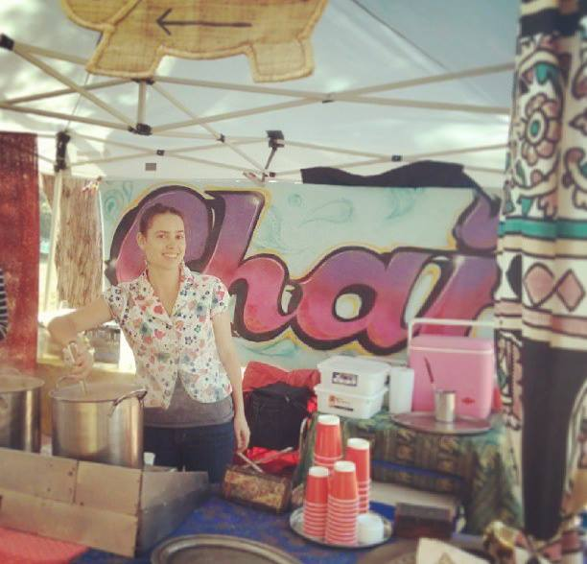

**Background:**

**Age:** 27-35

**Occupation:** Full Time jobs (works as manger of a local hostel) / Weekend Market stall owner (Chai Tea)

Personality:

Vegetarian.

Environmentalist.

Friendly.

Love locally produced food.

Cycles.

**what does she want to get out of this?**

Have a business which she is able to run without another job.

Make the best Chai Tea in Sydney

**what she does for jobs?**

Prepares the Chai Spice Mix

Prepares Iced Chai Tea. (Summer Only)

Sell Chai Tea (Hot / Cold)

**what tools?**

Cooking equipment

Smart Phone (Iphone)

Van

Computer

**Business Details:**

Mother and daughter run business. Produce a "Delicious freshly brewed masala chai!" serving at:

Bondi Farmer's Market Saturdays from 9-1pm

Marrickville Markets Sundays from 9-3pm

Sell:

Hot Chai Tea (All Year) Large: $4.80 Regular: $3.80  
Iced Chai Tea (Summer Time) Large: $4.80 Regular: $3.80

Spice mix (All Year) Bag: $14.50

Assorted cakes (only in Marrickville) $N/A

Social Media:

https://www.facebook.com/pages/Chai-Tent/506760149407442

http://instagram.com/chaitent

http://instagram.com/chailounge - (old one)

Blog Review:

http://nomvegefoodguide.wordpress.com/2010/05/24/the-chai-tent-addison-road-markets-marrickville/

Stakeholder Management

**Market Stall Owners - Buy-in**

**Why are they involved?**

Market Stall Owners will use our platform to sell their produce and in return we gain our revenue from them and the people who buy there produce.

**To what extent should they be involved?**

They are the people who make our platform popular and profitable.

**End Result:** Very important keep happy & informed on updates and changes.

**Customer buying local produce - Buy-in**

**Why are they involved?**

Customer will buy the market stall owners produce on our platform.

**To what extent should they be involved?**

They are people who produce the majority of our revenue. They could also become potential grower in phase two of creating a sustainable local food economy.

**End Result:** Keep them happy

**Local Bar/Stores/Restaurants - Buy-in**

**Why are they involved?**

"Wholesale Customer" will order market stall owners produce in bulk on our platform.

**To what extent should they be involved?**

They are people who produce the majority of our revenue. They could also be great sources of organic word of mouth.

**End Result:** Keep them happy

**CEO (Me) - Funding**

**Why are they involved?**

The person who is currently in charge of the platform direction.

**To what extent should they be involved?**

They are working to make sure the business & Platform is profitable and is moving in the right direction.

**End Result:** Keep informed about the business

**Investors - Funding**

**Why are they involved?**

Funding the start-up

**To what extent should they be involved?**

They should be made aware what is being done with their money & if they have knowledge used as a mentor to guide the start-up.

**End Result:** Keep happy so they continue to invest & Keep informed of business development.

**Marketing - Talent**

**Why are they involved?**

They are marketing to our potential customer and market stalls.

**To what extent should they be involved?**

They need to know about what going on with the product so they can market accordingly.

**End Result:** Keep informed of platform development.

**Sales - Talent**

**Why are they involved?**

They are Selling our platform to our potential market stalls .

**To what extent should they be involved?**

They need to know about what going on with the product so they can Sell accordingly. They are also the businesses ear to what customer need & Wants.

**End Result:** Keep informed of platform development.

**Developers - Talent**

**Why are they involved?**

The Coder who make our platform work.

**To what extent should they be involved?**

These people need to be heavily involved in making sure our platform working and can create new features.

**End Result:** Keep them happy & informed of business actions

# Product Requirements Document

**Minimal Viable Product (MVP)**

Jam Jar is to be used to help local business have access to similar resources that a large business would have (technology and business) but keep the personality &values at the core of what it does.

The Minimum Viable Product is to have an e-commerce platform which sell market stall produce. a key feature to be added is to identify the individual business that sell on this site (a profile page of sorts) which allow people to know who they are buying there produce from allowing a more personal purchasing experience.

To make revenue we will take a small percentage of the transactions and have a premium service to market stall in the near future.

## Technology

When it comes to this future platform I will minimize cost by not hosting it myself and instead run it from a Cloud Server.

I will most likely run it on one of the following platforms http://aws.amazon.com/ or https://cloud.google.com/ I choice these two more from a personal preference than any other reason. However these two company are large company with a very reliable infrastructure behind them which should allow my platform to run effectively without much down time.

It would will most likely be coded on a HTML 5 ,CSS 3, Ruby on Rails architecture as it seem to be very popular at the moment popular.

If I don't make this from scratch then I have found the following services

http://near-me.com/ & http://www.shopify.com/ as they seem to offer a very customizable platform to deal with creating an online marketplace however this could cost more in the long run and could be inflexible when we start adding new features to the system. A demo of both these system is required before proceeding with this.

## Roadmap

Please read the [Financial_Projections_and_Market Analysis.xlsx](Financial_Projections_and_Market%20Analysis.xlsx) Under "RoadMap"

## Product Life Cycle

|  |  |  |  |  |
| --- | --- | --- | --- | --- |
| **What is the team doing during?** | | | | |
| **Development** | **Introduction** | **Growth** | **Maturity** | **Decline** |
| * Developing the Critical features. * Contacting farmers markets to get on board with the programme. | * Refining critical features and adding secondary critical features. * Marketing to get people using product. | * Developing new feature to extend the product functionality * Expanding to new locations * work on community sustainability programmes | * working with top vendors to develop their product further. * Partner up with similar business (foodie based business, local communities) | * Find a Partnership? * Open-source? * Find alternative service for clients? |

|  |  |  |  |  |  |  |
| --- | --- | --- | --- | --- | --- | --- |
| Identify | Plan | Develop | Evaluate | Launch | Assess | Maintain /Kill |
| Is there a need for:  Online market stall platform  Talk with possible clients (Market stall owners, Local stores, restaurants , bars )  Understand what market stall vision for their product and how we can help to support this. | Design of the UX  Consider possible monetization models  Critical Features?  How will customer order & receive deliveries.  How will we express the market stall vision. | Use Cloud base technology to reduce server overhead.  Possible languages to use include PHP, Ruby on rails, HTML5 with CCS3  Possibly do some of the features manual at the start. | Test with variety of market stall owners.  Demo with potential clients at farmers markets  Test in a local Sydney suburb. | Market to Market stalls, Local business and customer who buy at market stalls.  Use Social Media to connect  with clients.  Find ways for this to get media interest online  Word of mouth though foodies (food blogs, restaurants)  Go out to local  business to show how it works.  Get customer and market stall vendors to spread the word of this platform . | Are people using it?  Are more than 35% of the user regular ordering a month?  Are we getting  a healthy retention on new clients  acquisition? | Kill if  more than one of these metric are not meet.  Maintain if we are getting regular active users find out why the other half are not active?  If we are getting  a healthy retention level looking in to  new features and optimizing old features. |

## Key metrics

**Acquisition**

People visiting the site for longer than 2minuites (anything lower class as bounce)

Bounce to acquisition ration need to be 2:5 (Bounce : Acquisition)

10% growth of new visitor month on month

35% growth of previous visitor month on month

likes/followers on social media,

60 likes/Follows per week

10% growth of this ever 3 months.

**Activation**

Creating a account on the site

20% of acquisitions active on first visit

New market stall Vendors are created on the site

3 new Store a month

**Retention**

People Opening Emails

(35% Emails are open/read)

70% of activation do more than 2 orders ever 6months

**Referral**

Sharing get a $10 discount off first order and $10 to existing customer balance.

33% of user share the link on social networks

10% of the links are clicked on.

**Revenue**

Customer make an Order

(30% people with an account make an order monthly),

Market stall vendors upgrade to premium subscription account

(15% of market stall vendors subscribe monthly)

(5% of market stall vendors subscribe Yearly).

## Storyboarding, Wireframes & Prototyping

The key feature of Jam Jar is to order products online. The wire frame & storyboard has been design to show the basic flow of ordering on this platform. I have gone with a similar design to Amazon.com in which you can add to cart before logging in.

The storyboard doesn't go into details of ordering quantities or what happened if you haven't register. It does show however the quick and simple approach I want the Platform to have from going from the homepage to make an order.

Home Page

State (logged In)

Checkout

State (logged In)

Market stall Store

State (logged In)

Checkout

State (logged Out)

Market stall Store

State (logged Out)

Home Page

State (logged Out)

Order Submission

State (logged In)

**Home Page State (logged Out)**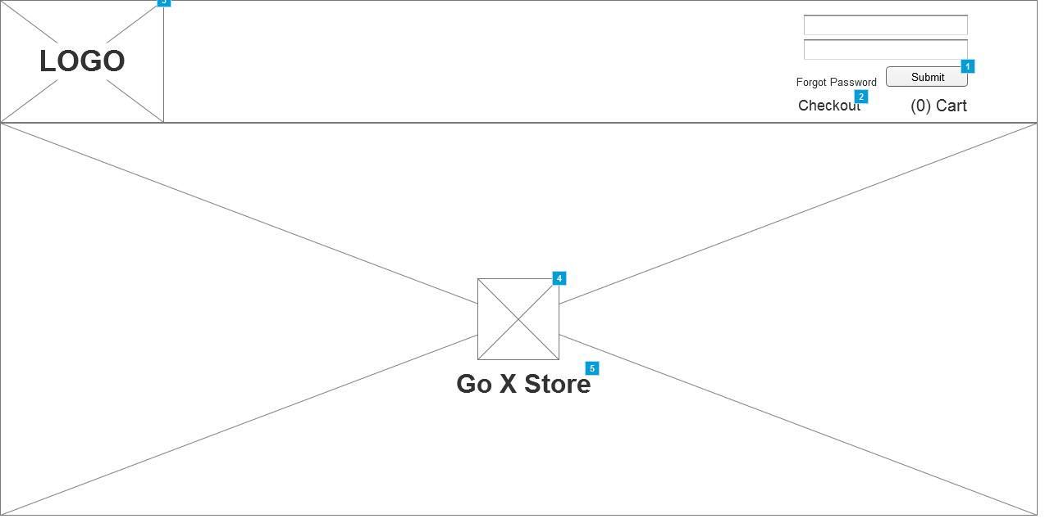

**Market stall Store State (logged Out)**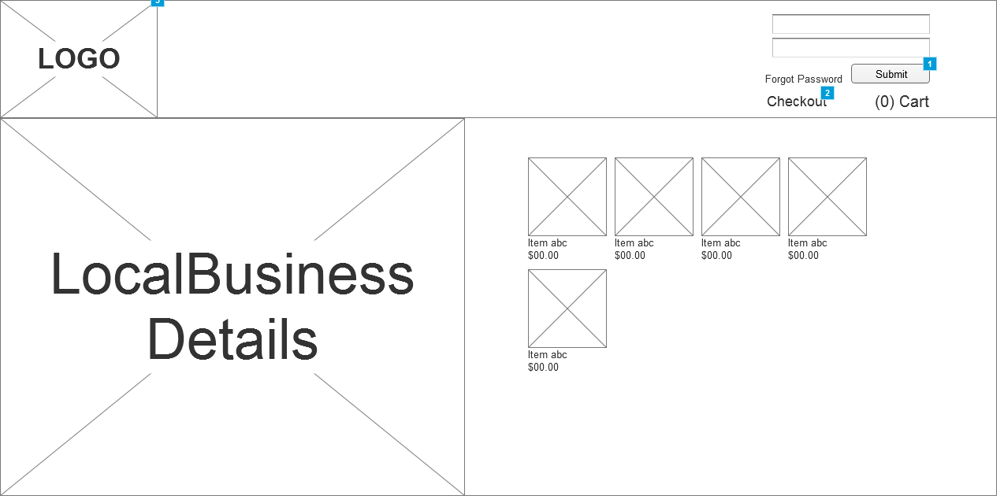

**Checkout State (logged Out)**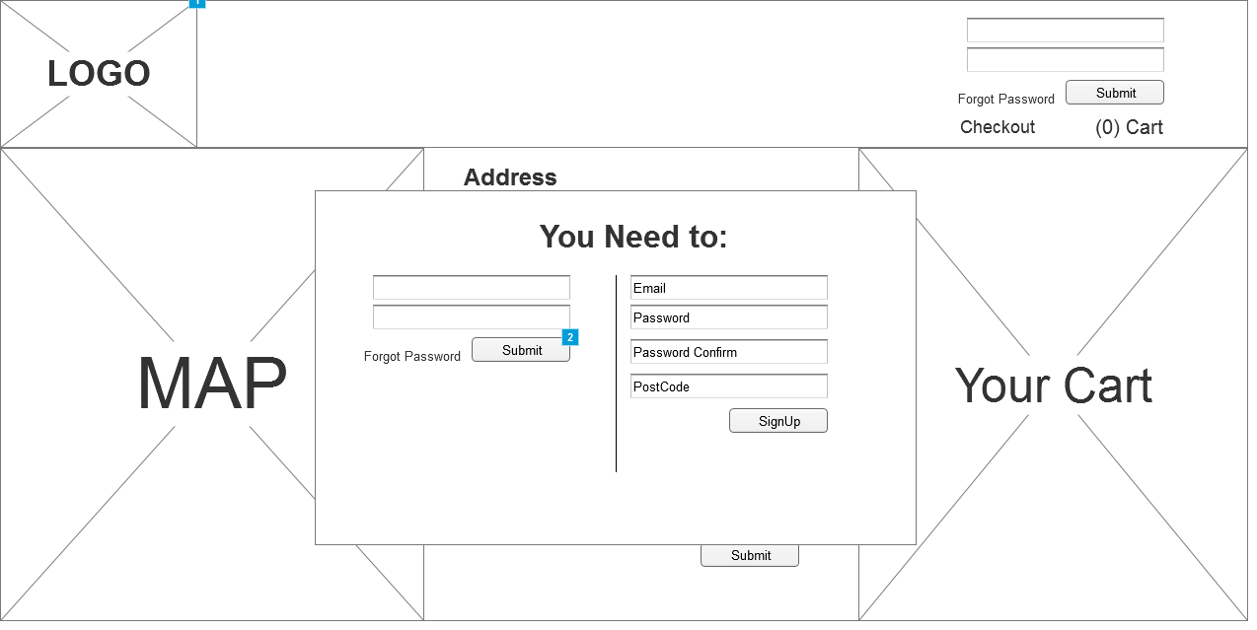

**Home Page State (logged In)**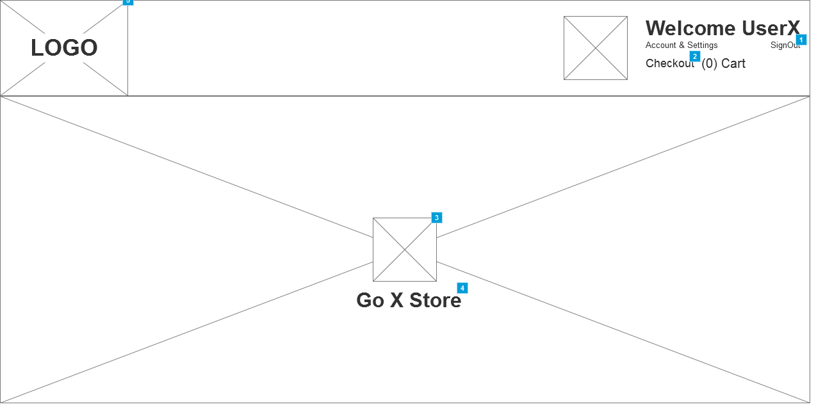

**Market stall Store State (logged In)**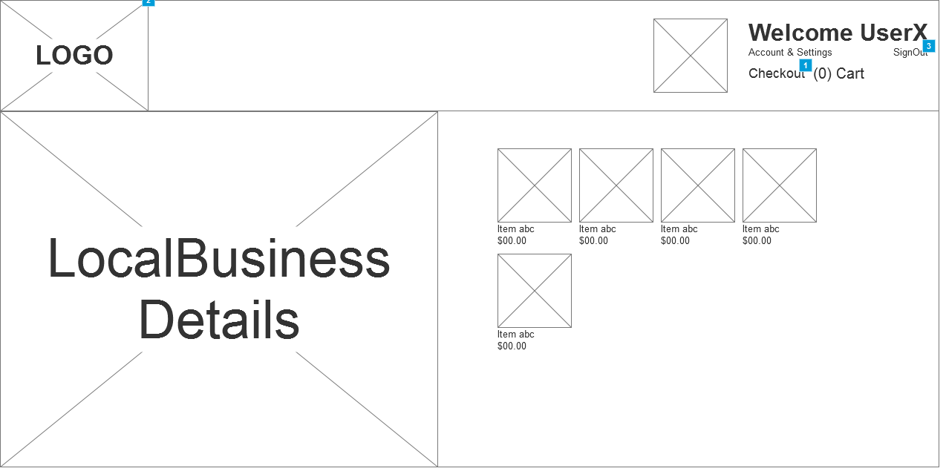

**Checkout State (logged In)**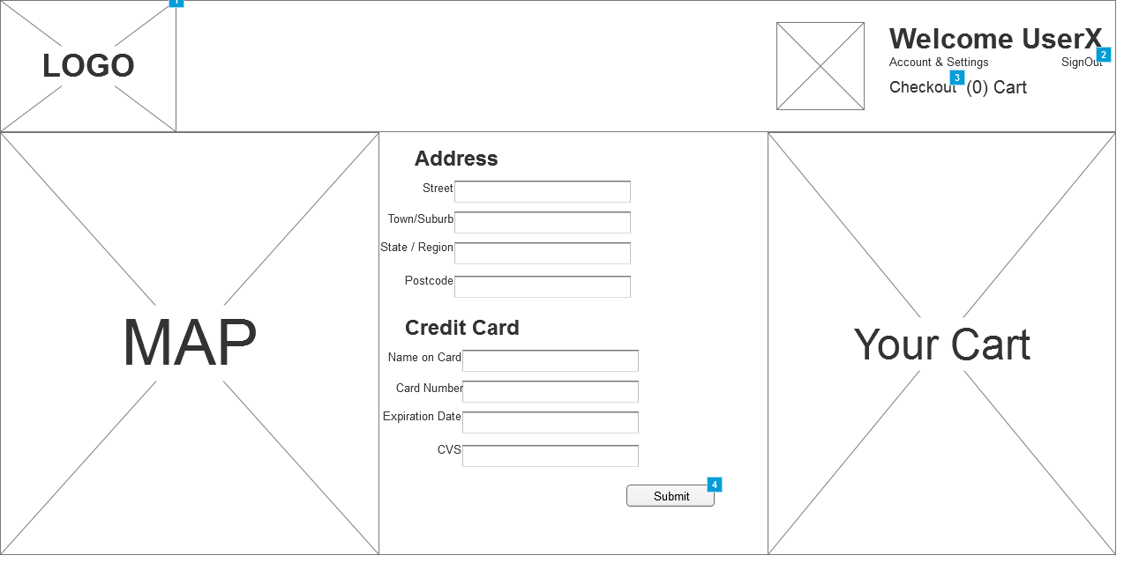

**Order Submission State (logged In)**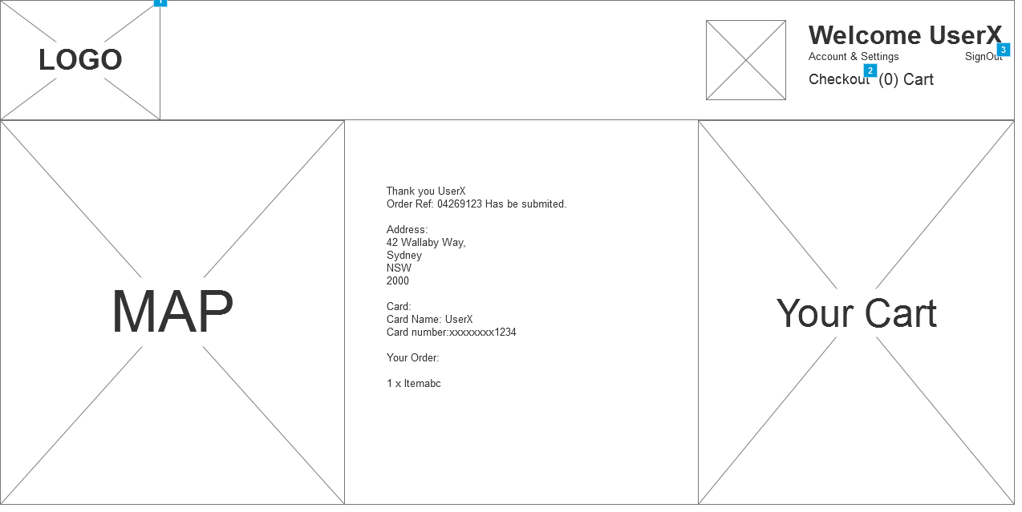

# Business Requirements Document

|  |  |  |  |  |  |  |
| --- | --- | --- | --- | --- | --- | --- |
| Business Model | | | | | | |
| **Key Partners** | **Key Activities** | | **Value Proposition** | | **Customer Relationship** | **Customer Segment** |
| * Local Markets * logistic Partners * Cloud Platform * Local community | * Develop Transparent Supply Chain * Eco-friendly * Local Sustainability * Support Local business | | * Connect Business to  -Business -Customer -Communities * Bring Local business Online * Transparency of business * Make the world: -Environmentally -Socially * Make the world globally sustainable though local sustainability * Support local business | | * Personal Business Values. * Delivery of homemade produce in a timely fashion. | * Market Stall * Homemade producers * People who love Homemade produce * Internet Users / ecommerce users |
| **Key Resources** | | **Channels** |
| * Local Markets * Online Platform * software developers * Logistics | | * Market Stalls * Social Networks * Web Platform * Delivering produce |
| **Cost Structure** | | | | **Revenue Streams** | | |
| Fixed | | Dynamic | | * Freemium * Ad-support, * Percentage of the Sale. | | |
| * Server Cost * Office & Utility Cost | | * Logistic Cost * Staff * Ad's/PR | |

|  |  |  |  |
| --- | --- | --- | --- |
| Value Proposition | | | |
| **Value Proposition** | | **Customer** | |
|  | **Gain Creators** | **Gains** |  |
| Jam Jar  -Expand local business to online market.  -Creates an online present for the business.  -Create greater aware of local business.  -connect to other local business  Alectronic  -Expand online presence  -Connecting with other local business  -Use technology to improve productive within local business. | - Gaining an online presence  - getting more sales from Selling their products online.  -connecting to a community of market stall owners. |
| **Product Service** | **Customer Jobs** |
| Jam Jar (Product) -  Sell Local Produce. [Transferrer]  Creates local business personalities. [Co-creator]  Alectronic (Service)  Social Media for local business. [Co-creator]  B2B Consultant. [Co-creator]  Technology & Business Consulting. [Co-creator] | Market Stall Vendors  -Selling their homemade produce.  - finding supplier.  -analysis business cost |
| **Pain Relievers** | **Pains** |
| Jam Jar  -Support people who lack technical knowledge  -Reduce uncertainly of selling at farmers markets  Alectronic -Support people who lack technical knowledge  -Support people who lack Business knowledge | -Lack of technical knowledge  -Lack of business knowledge  -Uncertainty of selling stock  -Not a sustainable business  -Lack of business connection |
|  |  |